**NOTES ON ANIMATOR’S SAMPLE STANDING GR FROM 10-29-21-OT IN NECESSARY ORDER DISCUSSION**

1. HAT

1. Vajra top added
2. Vulture feather added to vajra
3. Banners removed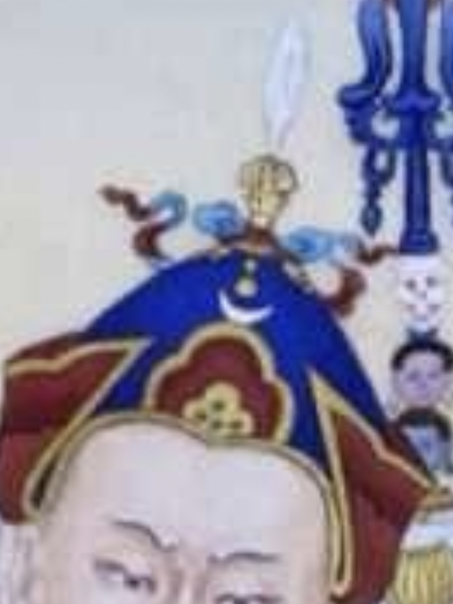
4. Blue top part

2. Add KHATVANGA under arm/in right arm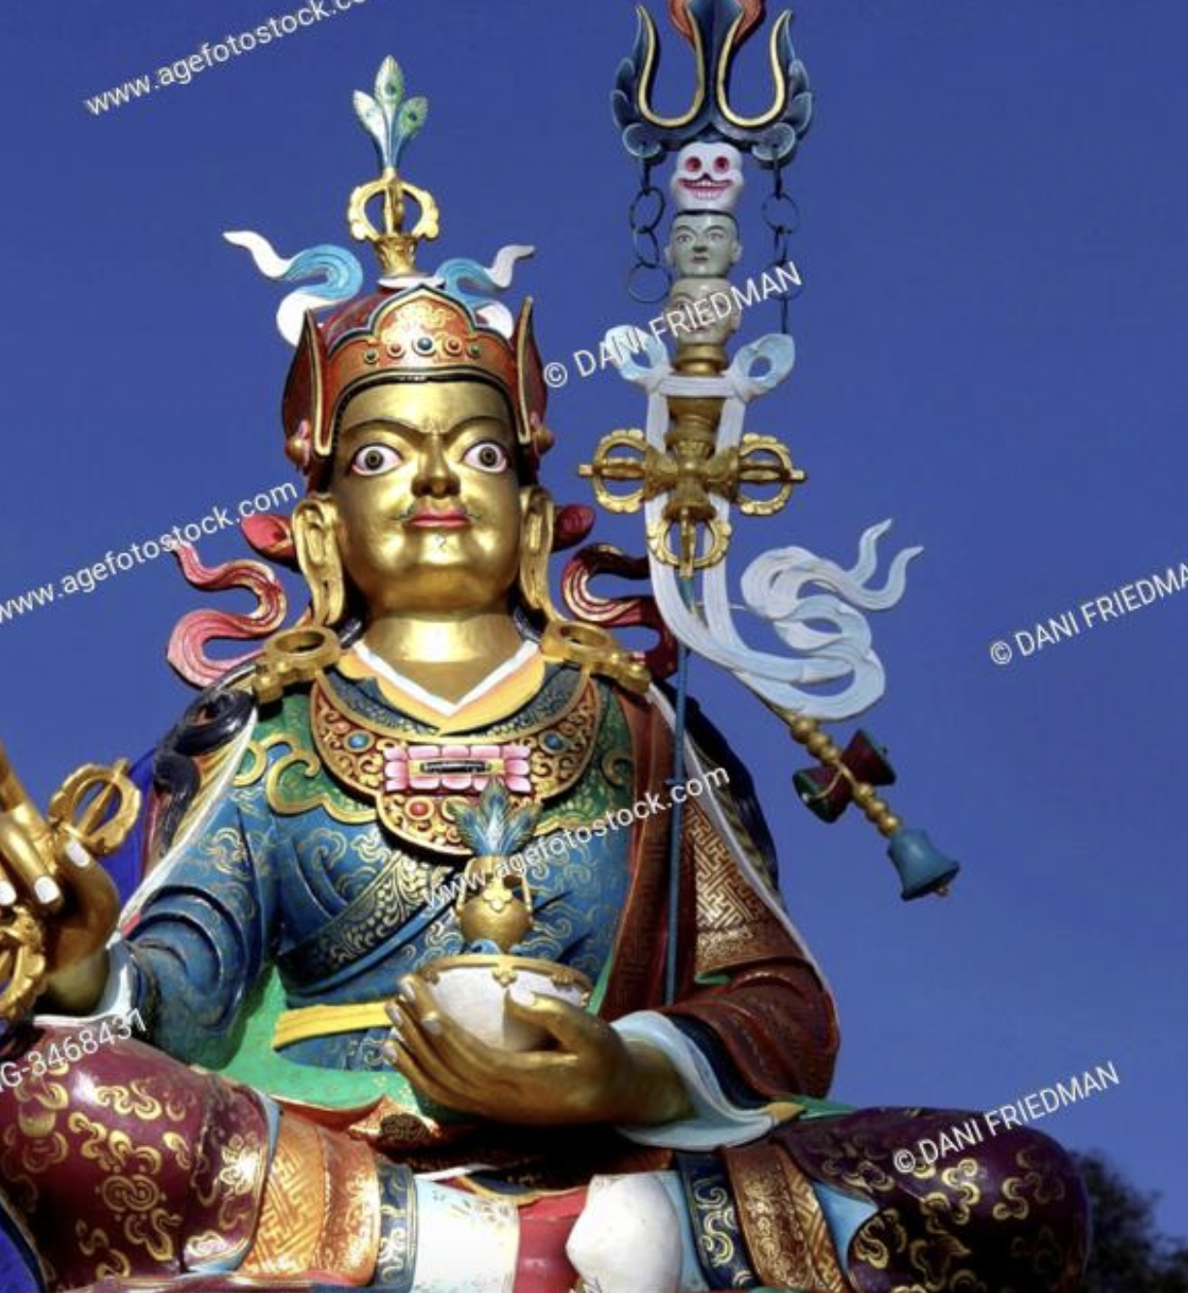

1. Trident
2. 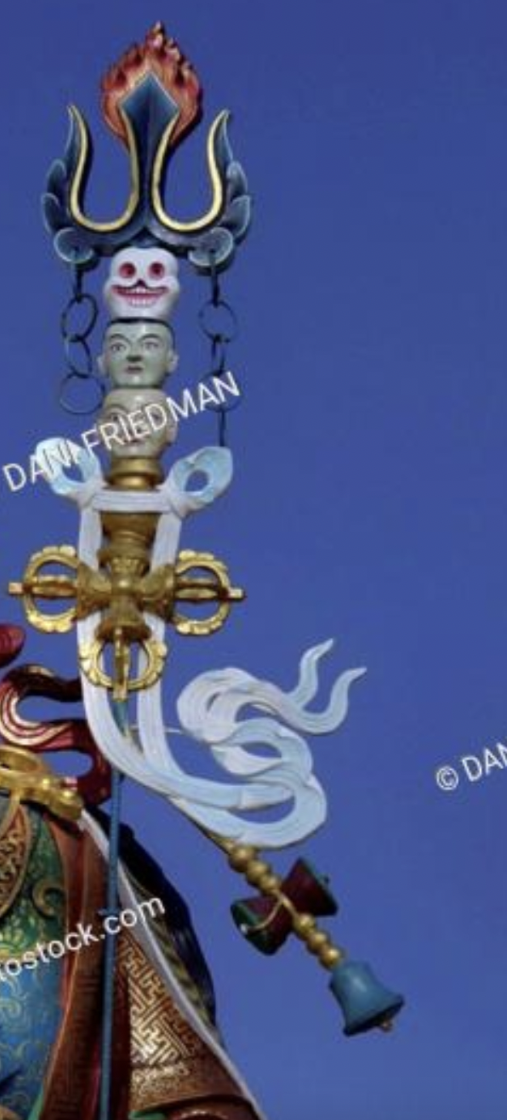Heads
3. Double Vajra
4. Tail

3. CLOAK

1. Make cloak Maroon brocade
2. Pattern 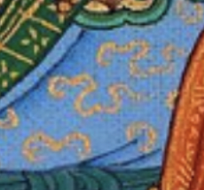

4. Robes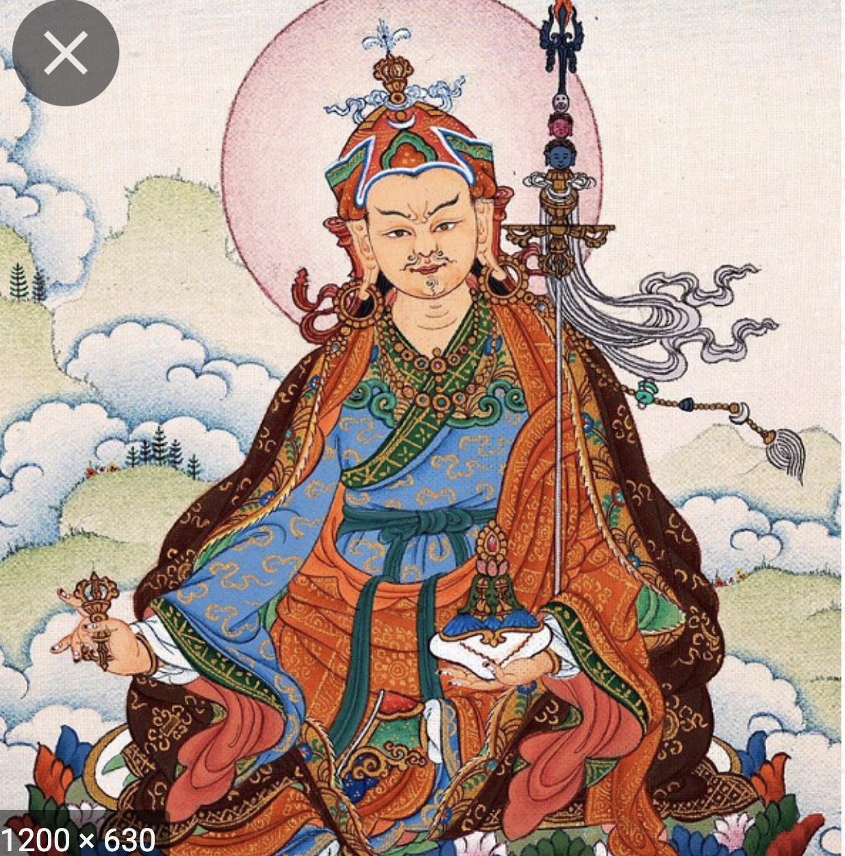

1. Outer
   1. Orange/red
2. Inner robes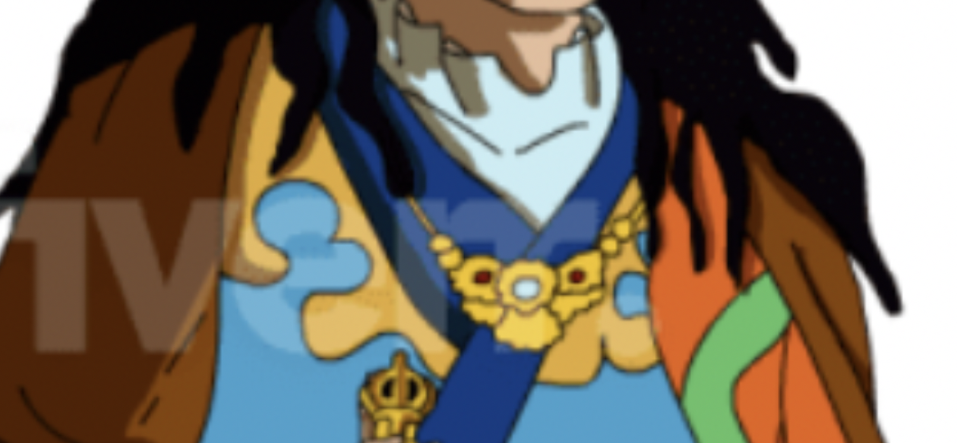
   1. Same pattern
   2. Darker blue
   3. Remove this gold trim resting on the top of the inner robe and make blue
3. Innermost robes should be white not light blue
   1. White around his neck
   2. White sleeves
   3. Shadows edited accordingly
4. Sash
   1. Dark blue

4. Feet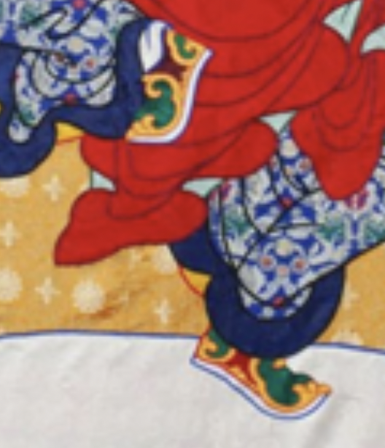

1. add shoes - Persian style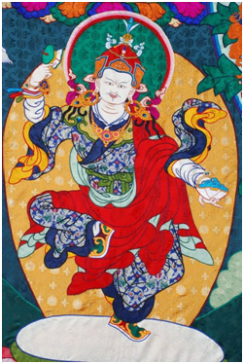

5. Face changes

1. MOUSTACHE & GOATEE like this
2. Remove sideburns; hair flows down at the back
3. Delineate dreadlocks
4. Eyebrows like below photo
5. Eyes like this 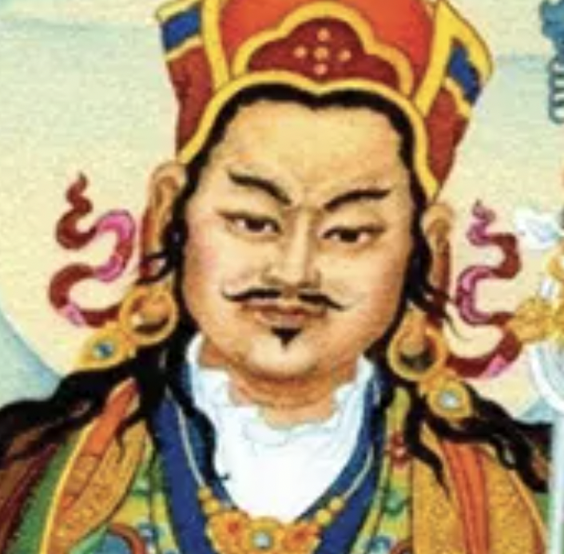

7 EARRINGS

1. Slight Enlarge
2. Change jewel to dark turquoise

8. Necklace

1. Center jewel turquoise
2. Rubies on either side
3. Same gold as vajra

9. Hand and fingers

1. Finger anatomy and positions normalized
2. Weird shadows on hand removed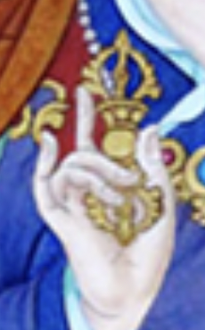

10. LEFT HAND HOLDING SKULL BOWL

1. Thumb normalization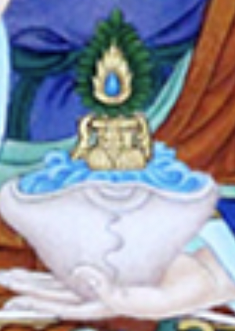

11. Skullcup

1. Long life vase inside corrected
2. Amrita color differentiated from other blues